SET 4 — Product Inventory Management
According to your experiment sheet, Set 4 uses Product Inventory data with Product ID, Product Name, and Quantity Available. The four tasks are a bar chart, stacked bar chart, scatter plot, and Tableau dashboard.
Dataset
Product | Quantity
Product A | 250
Product B | 175
Product C | 300
Product D | 200
Product E | 220

AIM
To analyze product inventory data using R programming and visualize the quantity available for different products using charts.
ALGORITHM
- Start RStudio.
- Create the product inventory dataset.
- Store Product Name, Quantity Available, Product Category, and Price.
- Create a bar chart to visualize the quantity of each product.
- Create a stacked bar chart to show inventory quantity by product category.
- Create a scatter plot between product price and quantity available.
- Add suitable titles and axis labels.
- Calculate the correlation between price and quantity.
- Display the graphs and result.
- Stop.
R CODE
inventory <- data.frame(
Product=c("Product A","Product B","Product C","Product D","Product E"),
Quantity=c(250,175,300,200,220),
Category=c("Electronics","Clothing","Electronics","Clothing","Electronics"),
Price=c(20,15,18,25,22)
)

# 1. Bar Chart
barplot(inventory$Quantity,
names.arg=inventory$Product,
main="Product Inventory",
xlab="Product",
ylab="Quantity Available")

# 2. Stacked Bar Chart
barplot(tapply(inventory$Quantity,inventory$Category,sum),
main="Inventory by Category",
xlab="Category",
ylab="Quantity")

# 3. Scatter Plot
plot(inventory$Price,inventory$Quantity,
main="Product Price vs Quantity",
xlab="Price",
ylab="Quantity Available",
pch=19)

# Correlation
cor(inventory$Price,inventory$Quantity)
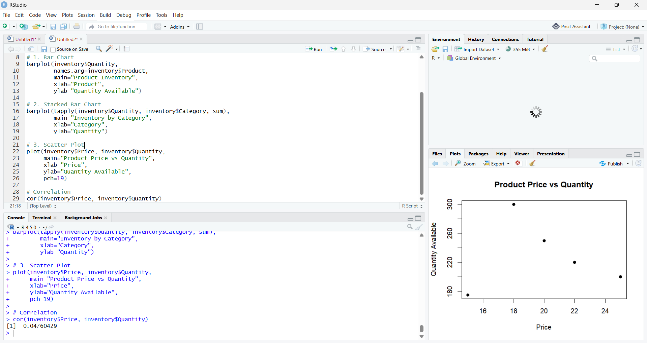
RESULT
Thus, the Product Inventory Management data was successfully analyzed using R programming. The bar chart, stacked bar chart, and scatter plot were successfully created to visualize product quantities and the relationship between product price and quantity available.

